JULY 2019 - JUNE 2020 - Newsletter
10, Samatadeep Bldg, Gr. Floor Aruna Kendra Dolarpada Girgaum
Bandra W Mumbai 400050 Talasari W Palghar MHR INDIA
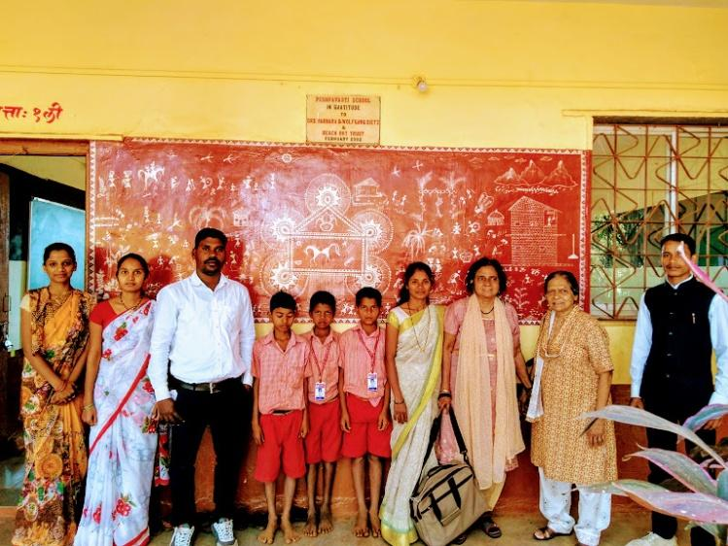
The year 2020 will be memorable in history because of the pandemic of the COVID-19 virus. This Corona virus spared no one, the rich, the poor, the celebrities, the common man, the politicians, the migrants, all were infected. It has baffled science in spite of the fact that it was expected to hit the world. It continues to challenge the medical experts in treatment and prevention. Suffice to say the world is a little wiser on how to deal with the virus now, but the Covid19 remains a mystery. We in Mumbai India had our share of woes and hurdles to face. Dharavi the biggest slum in Asia was hit very badly but with grit and community spirit the medical personnel and the public authorities could overcome the worst of the disease. The virus continued its spread throughout the country. Globally the future is uncertain regarding this pandemic but heroic efforts continue. The Reach out Trust in the period before the lock down continued its activities in the tribal area of Talasari in Maharashtra and in the slums of Mumbai.
Education: The Pushpa Vidhyala school in Dhangadpada, Zari Talasari had very good results with all students successful and 4 students attaining 70-75% in the 10 grade . Father Andrew chairman of Reach Out had arranged for special classes for these students and also a career guidance course. A medical checkup was arranged of all the children through the local Rotary club.
Santosh Meghwale, chairman of the school trust, the principal Ms Urmila Kakad and the staff had worked hard in preparing the students for the exams. From March end the school has been closed due to the pandemic.. There is hope that virtual schooling will start soon. Unfortunately most of the children will not have access to the technology it requires. We had to forgo our annual event in the school in March.
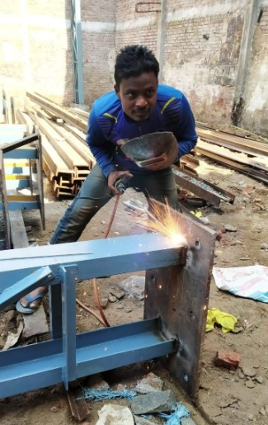
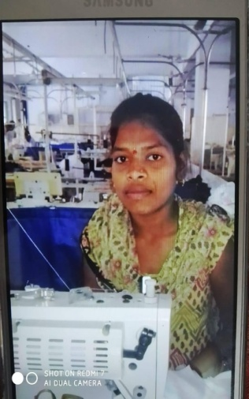
Dr. Tragler and Sr. Marie visited the school in February and felicitated the staff and the management on their good work. Students were given a course in leadership and Value Education in October. It was conducted by Fr. Michael Correa, Fr. Jacob Koli and Mr. Paryadi.Sr Marie and Ms. Effie Acharya were present. We are glad that other donors like Drs Barbara and Wolfgang Seitz, the Ginza Industrial Trust and the local Rotary club continue to assist the school.
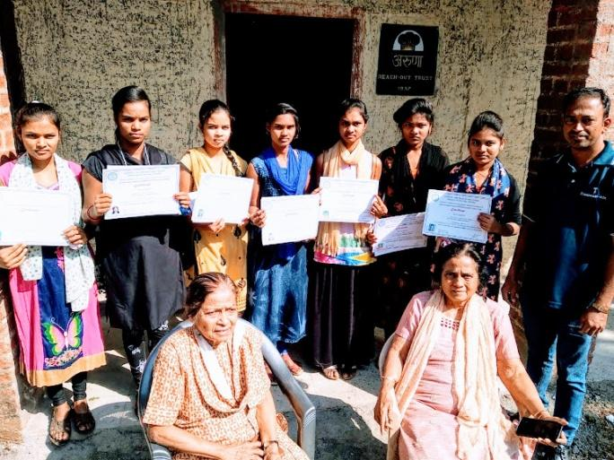
Vocational training: This continued in months prior to March end the time of the lock down. There were 2 batches of tailoring classes and welding one computer batch in the year. The students received government certification after completion of the 6 month courses. In 2019 a total of 20 students completed the welding course out of which 18 secured jobs in the nearby industrial belt. In tailoring 50 completed the course of which 40 secured jobs and 1o were self employed. In the computer course 18 completed the course and 10 secured jobs.
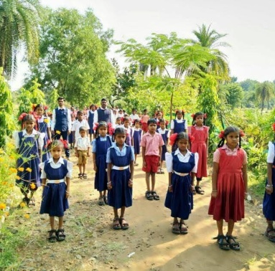
Environment and Health: The school children were given 2-3 fruit trees each by the forest department to plant in their own land. They also planted trees in the neighboring forest. The pumps we had installed last year were all functioning. The Trust pump with frequent use of the villagers was malfunctioning and had to be repaired .Villagers besides were also growing vegetables using water from hand pumps or from ponds. Yoga exercises were taught to the children, by the teachers which would be beneficial especially in the present Corona situation.

Administrative issues: The Trust property fencing was reinforced with wiring and tree planting .We had frequent changes of security and maintenance staff. Luckily Sunil Correa, our technical supervisor, was able to attend. In spite of Lock down conditions he spent 4 hours travelling to both the center and Bandra office once or twice a week. Transport is still to be organised in the current situation.
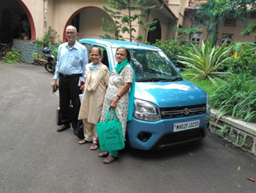
Since June private transport and a few public buses have resumed .Public transport by train is only for essential services. We have also started the process of getting the Non Agricultural certificate for the center in Dolarpada with the help of an architect. A digital survey was done of the land with the office and center. Sunil had to visit the government offices several times to get documents. It's a long procedure and may take six months and will cost the Trust a good sum of money. An excess fund from the previous donation was to be taxed instead, on advice from the auditors we used the money to buy a vehicle for the Trust. The previous vehicle was 16 years old and had so many repairs to be done that it may have to be scrapped.
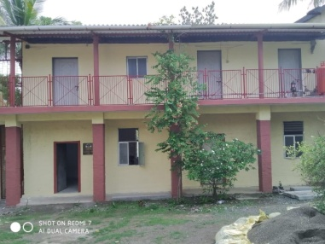
Sponsorship for student’s education: Selected students who had chronic medical problems or were from single parent households were given financial assistance for school or college tuition fees. Some students had only mothers surviving, as fathers had expired due to illnesses like HIV ,cancer or tuberculosis Others had parents with chronic illness , including a mother with stomach cancer. She is better now and the children are studying in high school. Another student with Aids lost her father this year also from HIV.

Covid 19 and its after effects in Mumbai and Talasari:
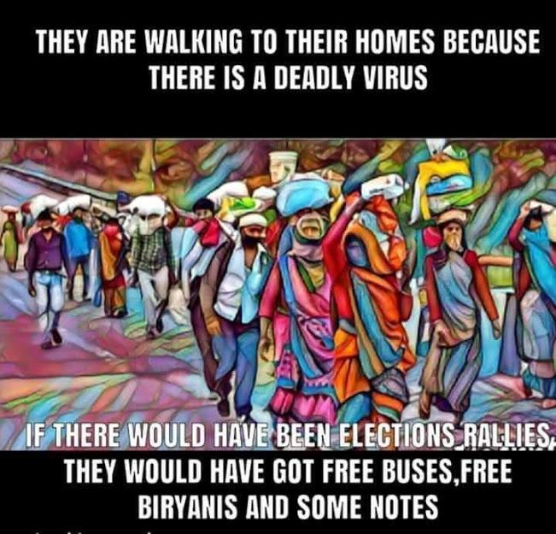
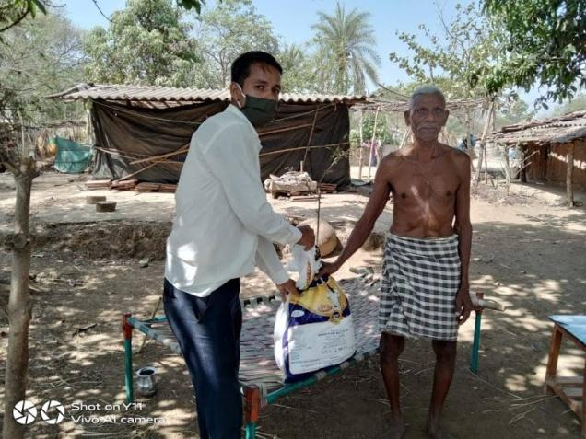
Mumbai was stricken with many hot spots of the virus especially in slums. The tremendous effort, especially by health, and sanitary workers, saved Mumbai . Today the pandemic has slowed in the cities but has spread to the outlying suburbs. The Reach Out Trust stretched its hand to help those suffering from the pandemic , especially the migrant families with supplies of nutrition and financial aid. The plight of the migrants was pitiful, they walked for miles along the road and the rail tracks .The tragic event was a train running over a whole group of migrants sleeping on the tracks, who had thought that the tracks were a safe place to sleep as most trains were not running. In Talasari too nutrition supplied by the government was distributed by the teachers to the jobless and the aged.

The rays of Hope were What was not Locked Down. The universe that was blessed with beautiful Sunrises and Sunsets in the clear blue skies, humans, birds animals could breathe increased Oxygen from the less polluted Air, the love friendship, family bonding that was created by the Pandemic and most of all the overwhelming Spirituality that the human Race experienced. We hope this will be sustained to make the World a Better place in the years to come.

Special Thanks: We give thanks to all our well-wishers and donors for their interest and donations to our projects. Without their support these projects would not have succeeded. Our appreciation and gratitude also goes to all our family members and friends from Germany, India, Austria and Australia. We are We are grateful to: Drs. Wolfgang & Barbara Sietz (Germany), Mrs. Regine Proebsting, Gaby and Wilhelm Lefeber and team of Indian Hilfe (Germany) We are also thankful for the timely assistance Sophia Polytechnic Mumbai and Mr Parag Rodrigues
We are very grateful to our ex-Trustee Dr. Christa Merkes Frei who does the German translation of the newsletter every year
We also appreciate the assistance of Mr. Rajgopal and Mrs. Effie Acharya and Trustees Sr. Marie Noronha and Fr. Andrew Rodrigues, Dayanand Ambolkar, Joseph Keve, Mrs Anadani Thakoor and Ms Marie Noronha.A million Thanks to Frau. Hannelore Huethmayr who coordinates the foreign transactions of the Trust and the donations of the Helfende Hand (Austria). Bouquets also to the generous contribution of Dr. Helga Lohmann (Germany) and Herr Friedrick Fuhrer Salzburg Austria. Many thanks to the Family Strassmayr, Families Johann and Rosa and Johanna Tragler,Gerhard Lobentaz, and Missionskreis Pettenbach- Austria for their kind assistance .
Dr. Ancilla Tragler
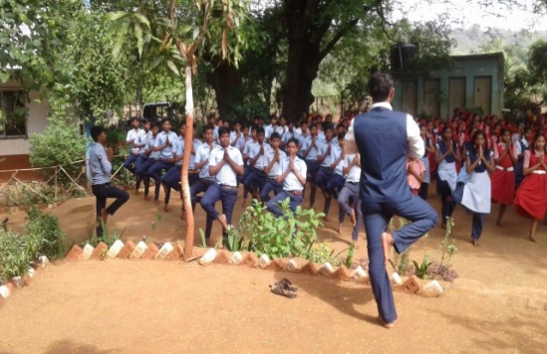
Secretary / Trustee Reach Out Trust
Tel: 091 967817028, email: atragler@gmail.com 601 Kala Niketan SV Road Bandra Mumbai 400050
304 Bridle Boast Road Cary NC 27519 USA
Reach Out Trust Website: www.reachoutmumbai.org Tel: 091 77680929
Our Bank Name: Indian Overseas Bank ,36th Road, Radhasoami Apts, Bandra (W), Mumbai 400050, Account No: 012801000012770 Swift Code No: IOBAINBB100028
Contact Person for Foreign contributions Hannelore Huethmayr Lärchenweg 10A – 4644 Scharnstein, Österreich (Austria) email: huethmayr.hannelore@a1.net
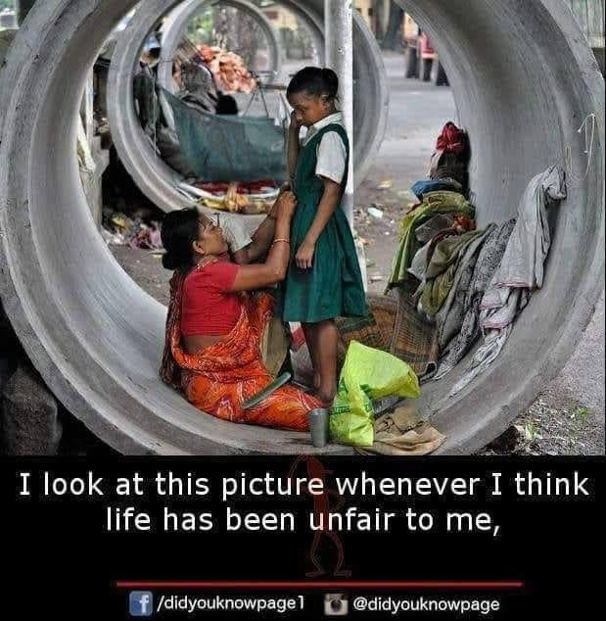
Sparkonto in Österreich Helfende Hand BOMBAY – Indien RAIFFEISEN Meine Bank – Österreich BLZ (Bankleitzahl) 34380, BIC: RZOOAT2L380 IBAN: AT42 3438 0000 0382 0479

