July 2016- June 2017

This year marks 35 years since the Reach Out’s inception and 30 years since it has been contributing to welfare of the Tribal community We are presently working in Girgaum village of Talasari W in the Palghar district of Maharashtra 150 Km North of Mumbai A Research project in the year 2000 defined our goals from the peoples needs.. We have been involved mostly with education, vocational skill training health and environment programs in the last year which the people desired.

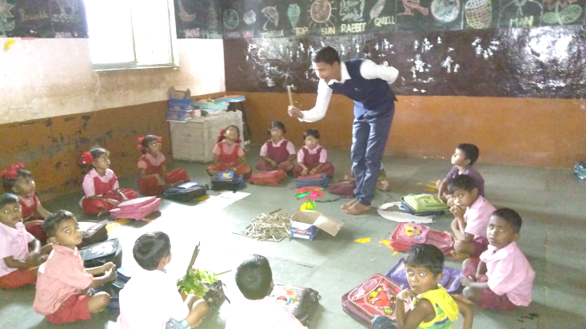
Education This is the third year that the Pushpa Vidhyala village school that we assist, has sent students for the State Board exams of the 10th Grade The success rate was about 75%for the 22 students that took the Board exams Altogether 270 children have enrolled this year in the school.
The school plans excursions encourages sports,culture and arts together withaccademic studies.Children planted trees on the roads,they also took part in interschool sports like kabadi and took part in various craftsand art in the holidays.

We carried out a survey ,and from the data we collected., there were 50 children whose families possessed very little land or were landless and were of very low income
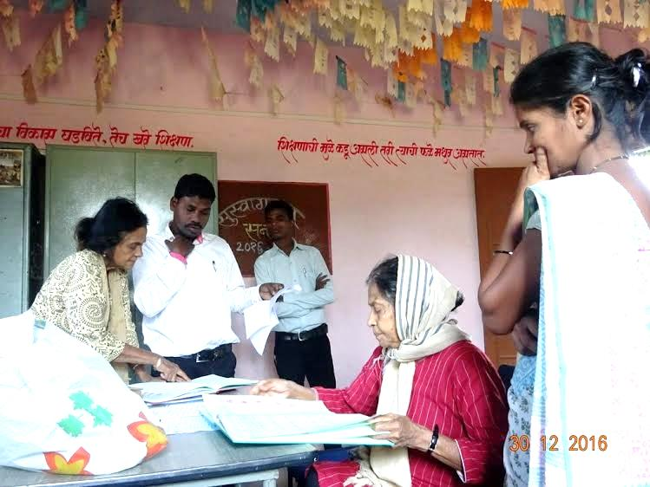
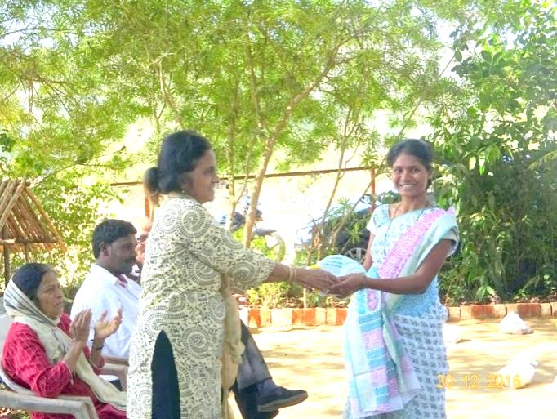
We assisted these families with nutritional supplies. Health needs were taken care by the government services or Dr Tragler on her visits Repairs of the school fence and gate were carried out We also provide the children with some fruits from the farm We had a felicitation for the teachers specially for Ms Urmila Kakad the headmistress who has worked for the school for 11 years and Ms Savita Bhoye the Primary school head mistress There were 11 teachers in all
We assist 5 teachers in payment towards their salaries The school is also being assisted by the Rotary club , a corporate sector and Drs Barbara and Wolfgang Seitz who visited the school in March. The school arranged for a program to welcome them and it was a good occasion where staff, children and donors could meet,

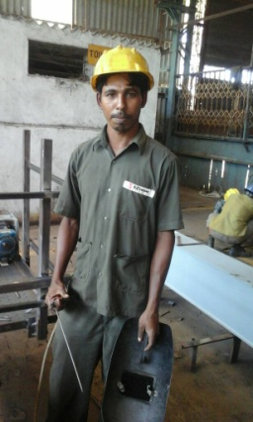
Vocational Training This year we are proud to co ordinate with Baraka of the UK for computer courses for the youth Mr Nigel Haunch visited our project and agreed to get funds for the project for the purchase of computers and also providing for the stipend for the teachers maintenance for the computers. Through Reach Out we got the furniture required We also provided solar panels for the functioning of the computers. One batch of 8 students has completed the the basic computer course and the the next batch is ongoing.
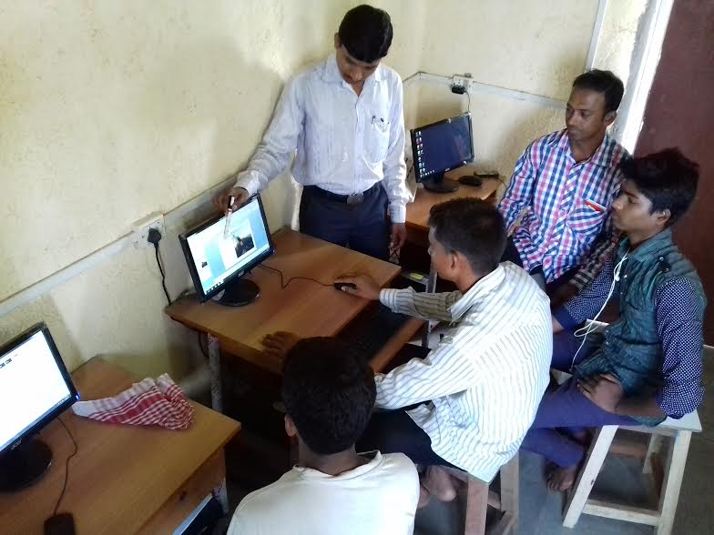
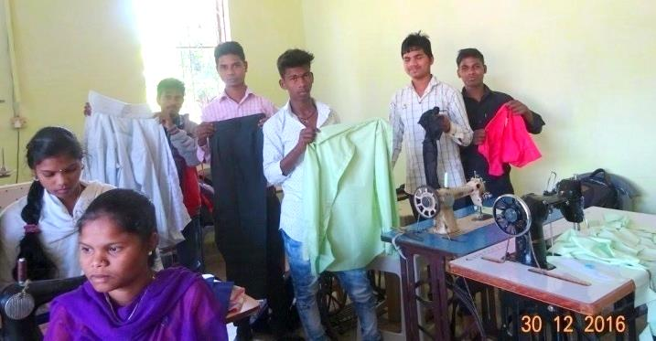
The welding course was completed for one batch of students. The tailoring training was conducted by Ajit Kondare for 2 batches of 20 students each. Sunil Correia besides conducting the welding course also does recruitment and placement of the students. Most of the youth get employment in the neighboring industrial area or are self employed The welding students have been involved in making grills for windows doors and gates. It is good to see all of them gainfully occupied The tailoring students both girls and boys are earning Rupees 7 to 8 thousand a month, while the boys who have completed welding earn Rupees 8-9000 thousand a month.

Environment and Trust lands
Arun Kharpade a tribal from a neighboring village, lives on the premises manages looking after the maintenance. Sunil and Dayanand Ambolkar supervise the administration on a daily basis .There were some issues about the land and Fr. Andrew and Sr Marie Trustees managed to take care of this while, Dr Tragler was abroad. They prepared the correspondence and visited the office in Palghar We are also pursuing other records from the local office..Hopefully these matters will get settled soon.
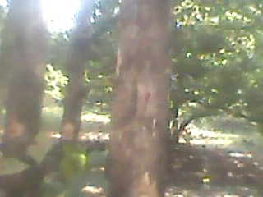
This year we decided to sell the teak trees on the land They were about twenty years old and had reached the criteria of size for sale. There were many hurdles and fees to be paid so finally the amount we got from the sale was not as much as we expected but we got the best price available.
There were some thefts of Trust property like submerged water pumps, drainage pipes .and electric cables We made police complaints also we are working with the local village authorities There are local youth who engage in vandalism,. On our premises we made secure most of our property with better fencing and gates We have also engaged one more security personnel
The police have promised to make rounds in the area
Looking at the brighter side of things in June we had a good sale from the mangoes which had a good yield and also from the sale of chikoos the local fruit grown on our farms through out the year. The staff have to cope with electric failures so there is water shortage often .We use only manure strengthened by vermi culture Maybe this is the reason the fruits are so good. .
Sponsorship Program for Urban children in Mumbai
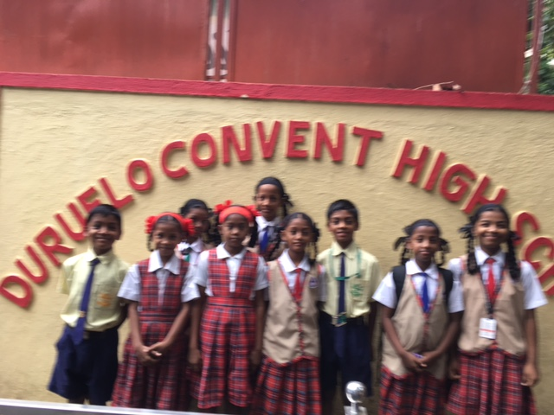
We are assisting girl students from migrant families enrolled in the Durello convent school and are from low socio economic background, also students where parents are suffering from chronic diseases like Aids, TB and cancer. In 3 of these families one or both parents have Aids In 2 cases the father has expired from Aids.In one family the father had a stroke and was unable to work. The mother works full time and she was very happy this year when her 2 children passed the 10th grade and have succeeded enrolling for college education. We are helping about 20 such children with payment of fees and money for uniforms
Follow up Programs We had applied for bore wells for 20 families in the nearby villages This project did not come through in spite of repeated reminders Our staff visited the Women’s groups we had started ,Some have joined the government program most are continuing savings

Special Thanks :We give thanks to all our well-wishers and donors for their interest and donations to our projects. Without your support these projects would not have succeeded. Our appreciation and gratitude also goes to all our family members and friends from Germany India Austria and UK.
We are grateful to:
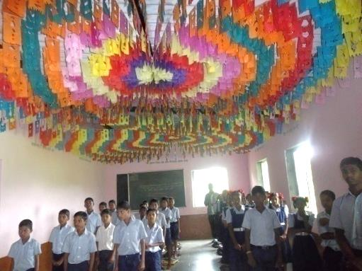
Drs. Wolfgang & Barbara Sietz (Germany)Mrs. Regine Proebsting, Gaby and Willem Lefeber & team of Indian Hilfe (Germany), S. N. Iyer Q. C. & Irene Iyer Charity Trust (Mumbai, India) .
We are also thankful for the timely assistance of Sophia Polytechnic Mumbai.and Baraka UK
We are very grateful to our Trustee Dr. Christa Merkes Frei who does the German translation of the newsletter every year.
We also appreciate the assistance of Mr. Rajgopal and Mrs. Effie Acharya and Trustees Sr. Marie Noronha and Fr Andrew Rodrigues, Dayanand Ambolkar , Joseph Keve, Mrs Anadani Thakoor and Ms Marie Noronha .
Our special thanks to Mrs. Hannelore Huethmayr who coordinates the foreign transactions of the Trust, and members of Helfende Hand (Austria).

Bouquets also to the generous contribution of Dr. Helga Lohmann (Germany) and Herr Fritz Fuhrer Salzburg, Family Strassmayr, Families Tragler and Missionskreis Pettenbach, Austria for their kind assistance.
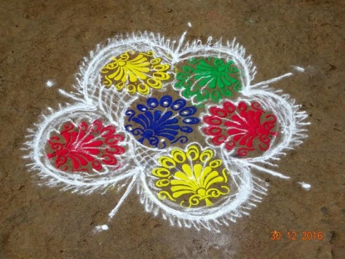
Dr. Ancilla Tragler
Secretary / Trustee
Reach Out Trust
Email: atragler@gmail.com
Contact:
Tel: 0091-22-26451334/9967817028
Website:www.reachoutmumbai.org
Aruna, Kendra Dolarpada Girgaum
Tel: 091 7768092962
Email: reachoutmumbai@gmail.com .

Our Bank Name:
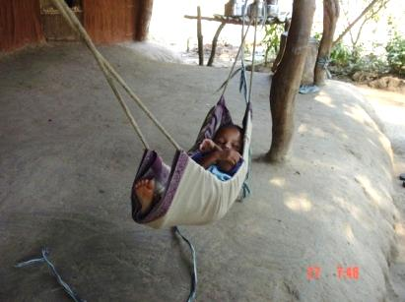
Indian Overseas Bank
36th Road, Radhasoami Apts,
Bandra (W), Mumbai 400 050,
Account No: 012801000012770
Swift Code No: IOBAINBB100028
Contact Person:for Foreign contributions
Hannelore Huethmayr Lärchenweg 10
A – 4644 Scharnstein, Oesterreich

Sparkonto in Österreich
Helfende Hand BOMBAY – Indien
RAIFFEISEN Meine Bank – Österreich- Konto-Nr. 20479
BLZ (Bankleitzahl) 34380, IBAN: AT42 3438 0000 0382 0479
BIC: RZOOAT2L380

Email: huethmayr.hannelore@a1.net

